**PRACTICAL-4**

**AIM:**

An organization is having 3 braches at 3 different locations. The founder of organization wants to configure the WAN connection amongst all the branches for better communication, file sharing and resource sharing. Demonstrate the dynamic routing configuration using RIP protocol for the given scenario using cisco packet tracer.

**THEORY:**

**RIP:**

* RIP stands for ROUTING INFORMATION PROTOCOL.
* RIP is a dynamic routing protocol which uses hop count as a routing metric to find the best path between the source and the destination network
* It works on application layer of OSI model
* RIP also do the updates of the network are exchanged periodically.
* Full routing tables are sent in updates.

**HOP COUNT:**

* Hop count is the number of routers occurring in between the source and destination network.
* The maximum hop count allowed for RIP is 15 and hop count of 16 is considered as network unreachable.

**PRACTICAL IMPLEMENTATION:**

* As there are 3 branches at different location, so we will take 3 routers.
* For simplicity, we will take only 1 PC for each router.
* Here, we are using Router 2811, which have 2 ports, but we require 4 ports

in each router so first we will add ports to the routers.

* To do so, turn off the router and add the ports from the modules menu.

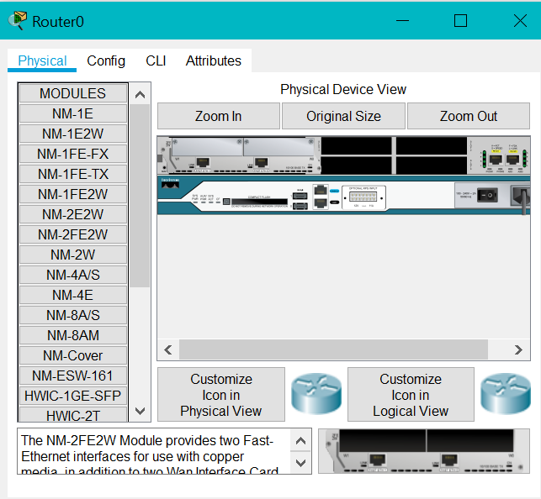

* Router after 2 extra ports added.
* Connect the routers with PC and neighbouring Routers.

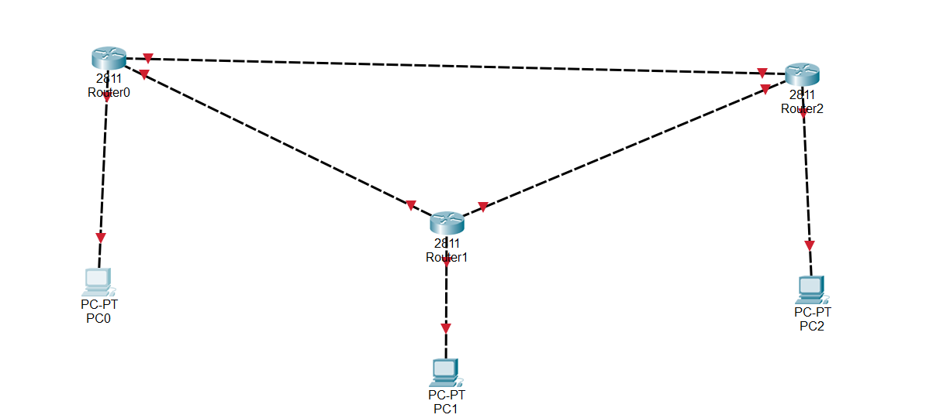

* The topology will look like the above image.
* Now, define and configure the IP addresses and define the networks.

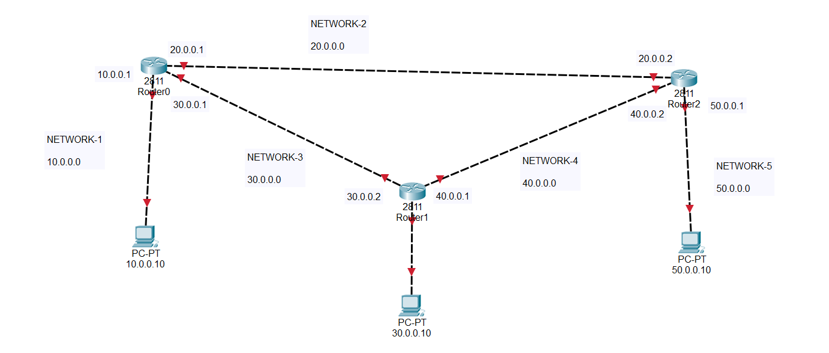

* Now, we will configure the Routers and assign IP address to PCs.

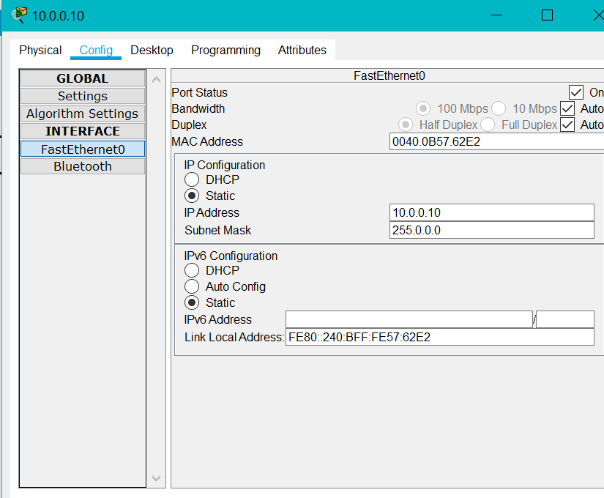

* We will also assign Default Gateway

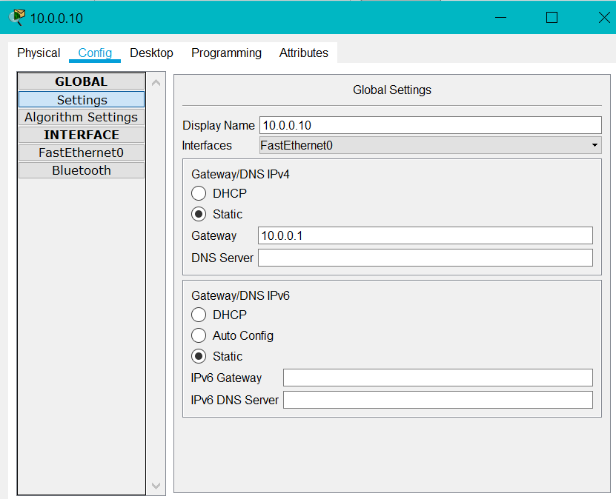

* Configure the Router settings.

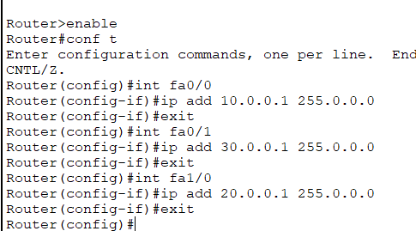

* Perform the same steps for all the Routers.
* Once the above steps are performed, all the arrows will be having green ticks.

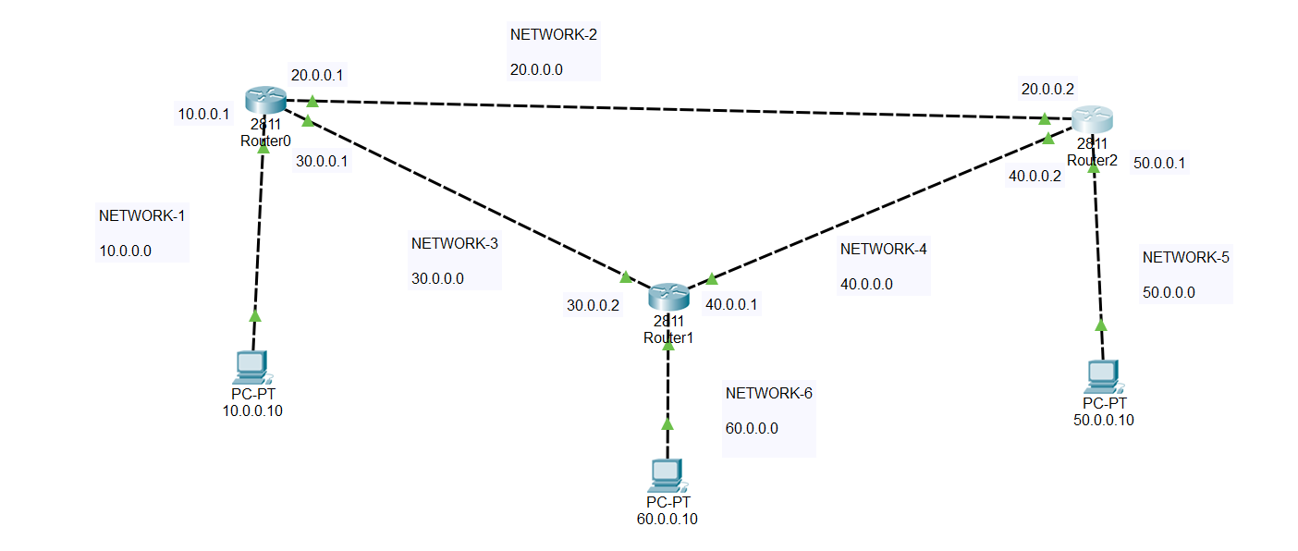

* Now we will do configuration for RIP.
* Basically, we have to provide the information of neighbours to all the routers.
* Perform the following steps to do soas mentioned in the image below:

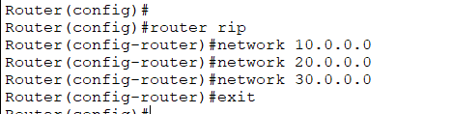

* To see the routing table, exit the config mode, and then type show ip route

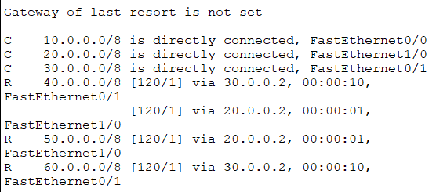

* So, we have established WAN using RIP.

**NETWORK TESTING:**

* To test the WAN, we will use PDU method.
* Initially, for 2-3 attempts, it will fail but then it will work successfully.

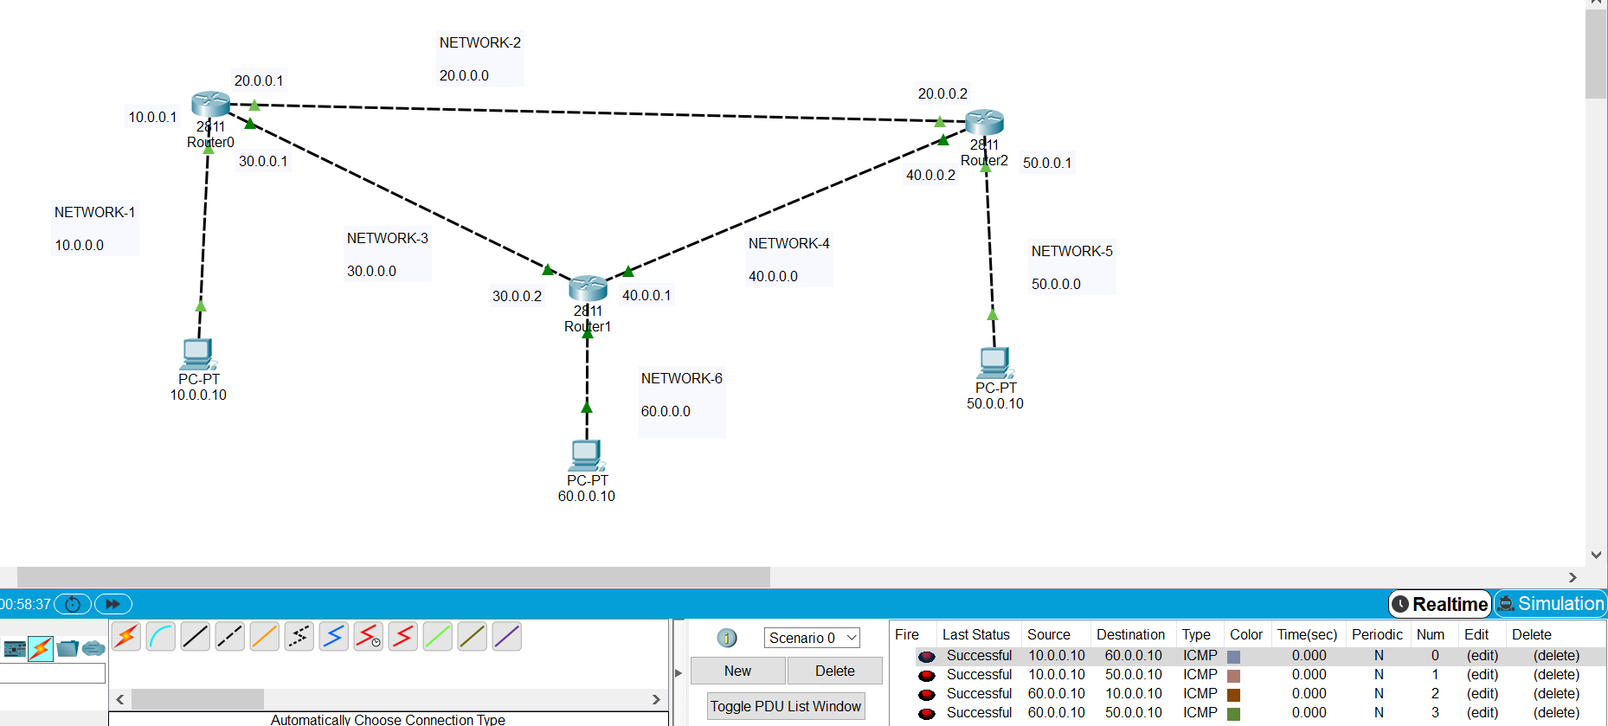

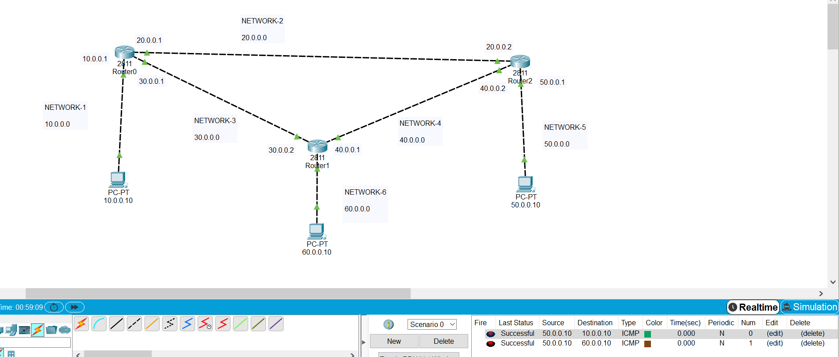

**CONCLUSION:**

* By performing the above practical, we learnt about the concepts of RIP and how it works, and also how to establish WAN using RIP.